**“ASSIGNMENT NO 2”**



Muhammad Ali

Registration No: 19PWCSE1801

Class Section: A

**Submitted To Sir Rehmat Ullah**

**Date:(December 18, 2020)**

**Digital Logic Design**

Department of Computer Systems Engineering

University of Engineering and Technology, Peshawar

**1.Think of ten 3-variable functions and design circuits for them using sum-of-minterms technique.**

**No.1:-**

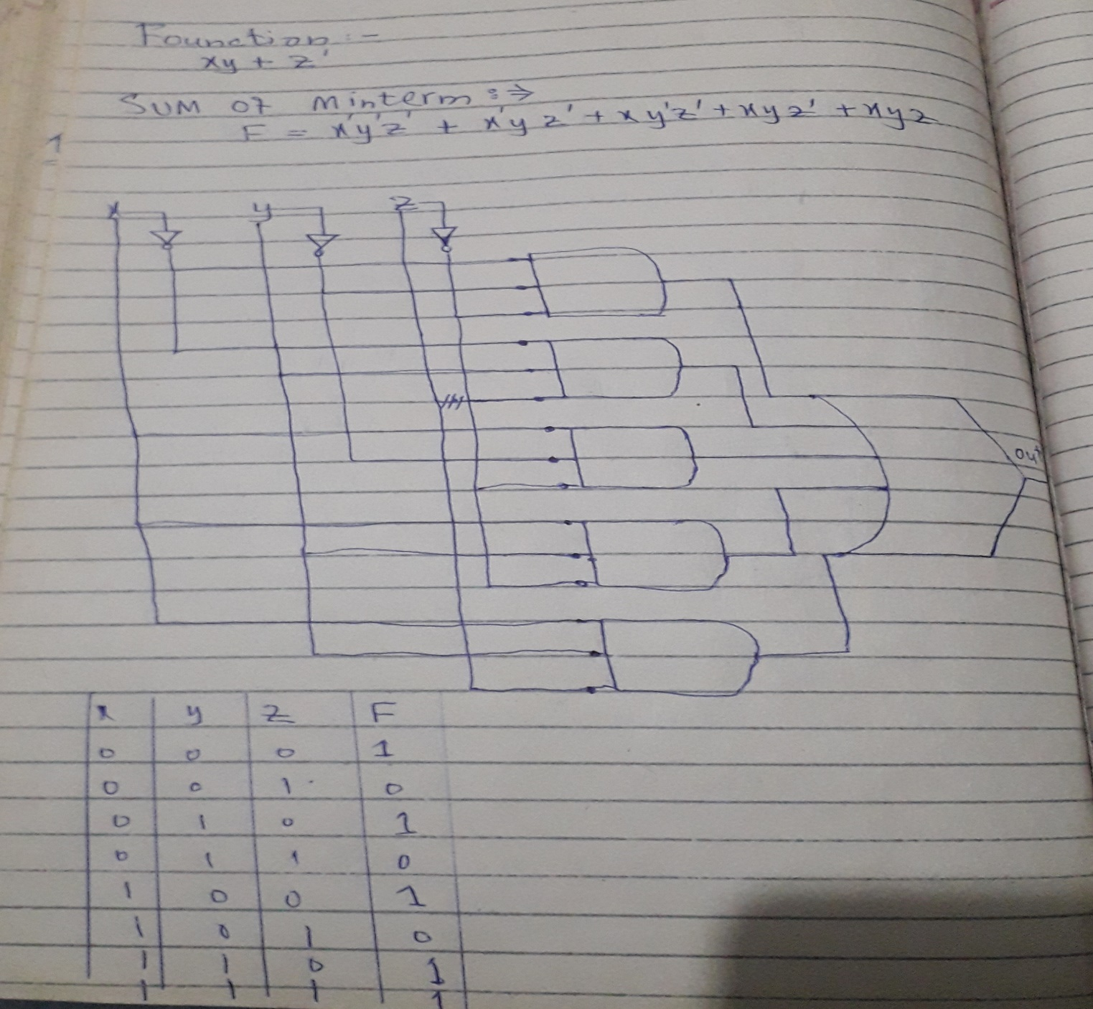

**No.2:-**

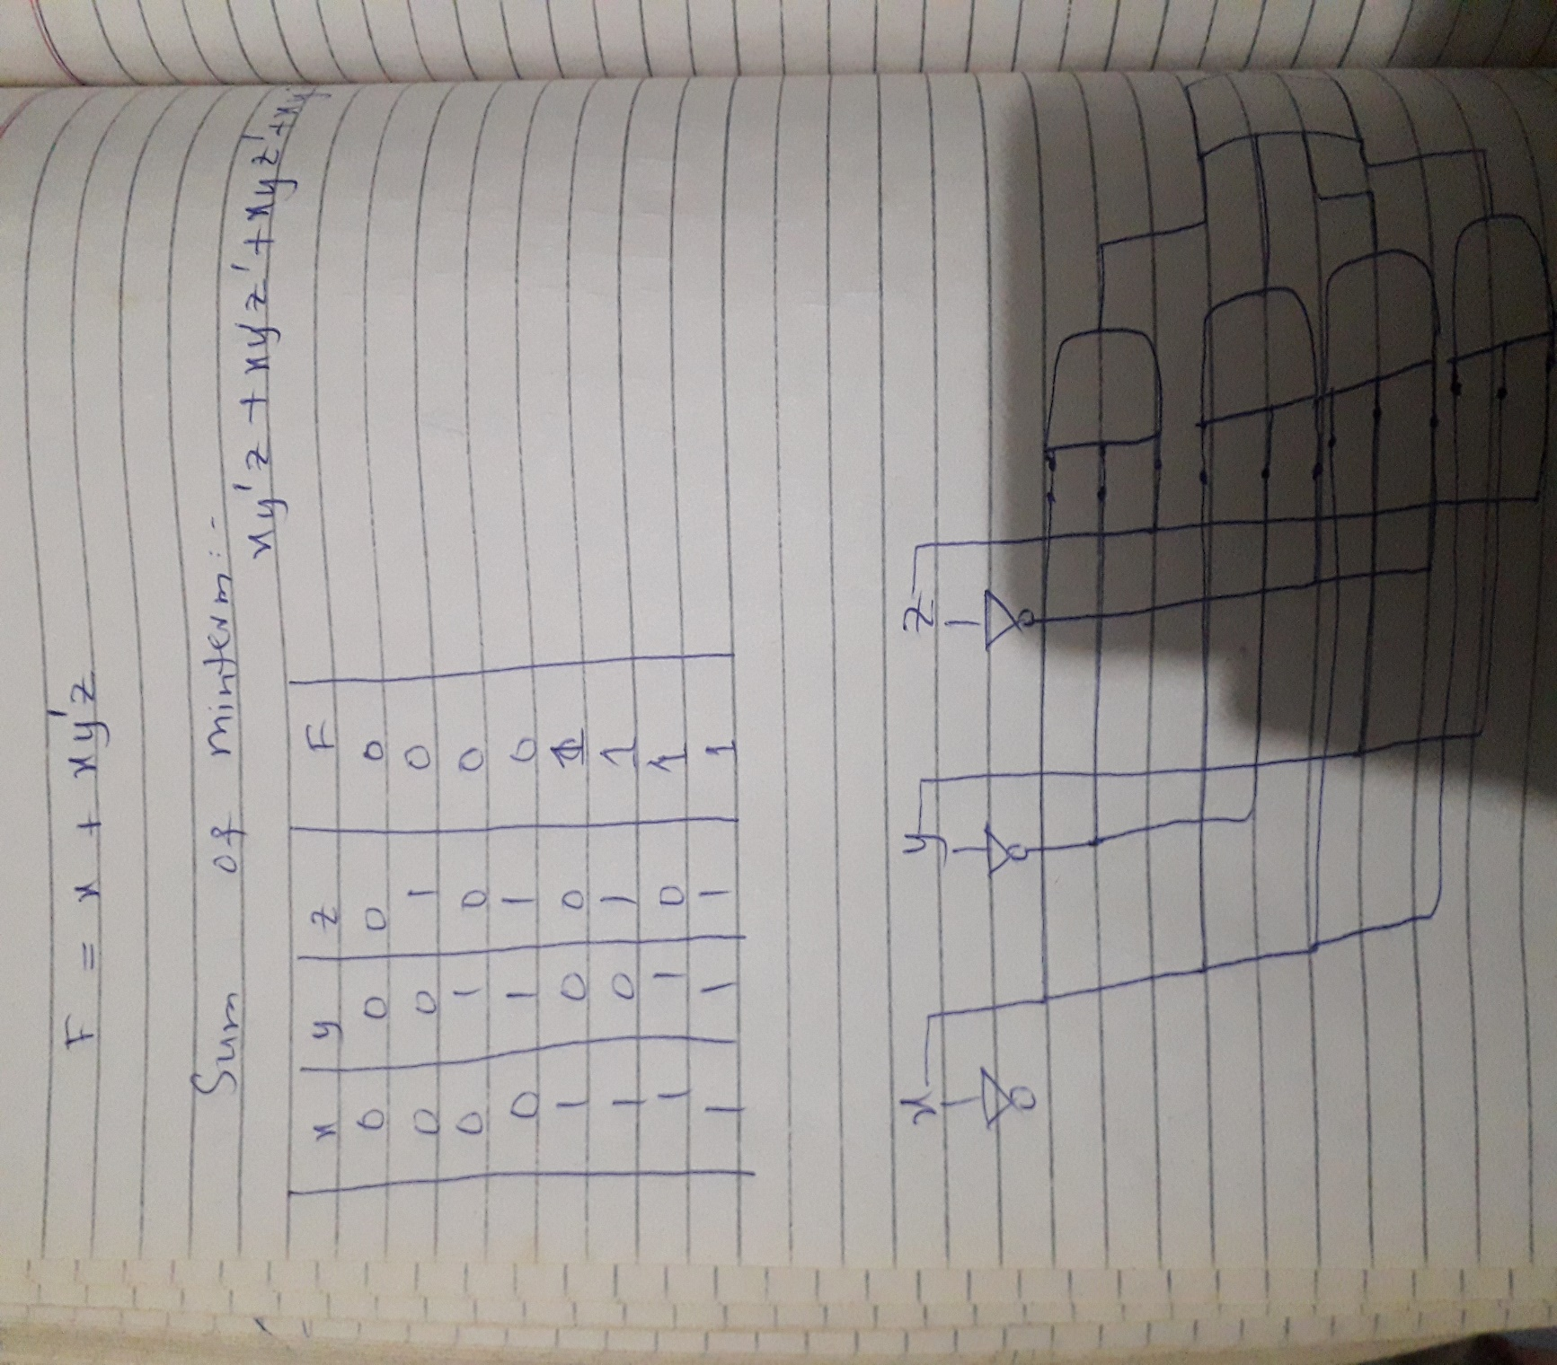

**No.3:-**

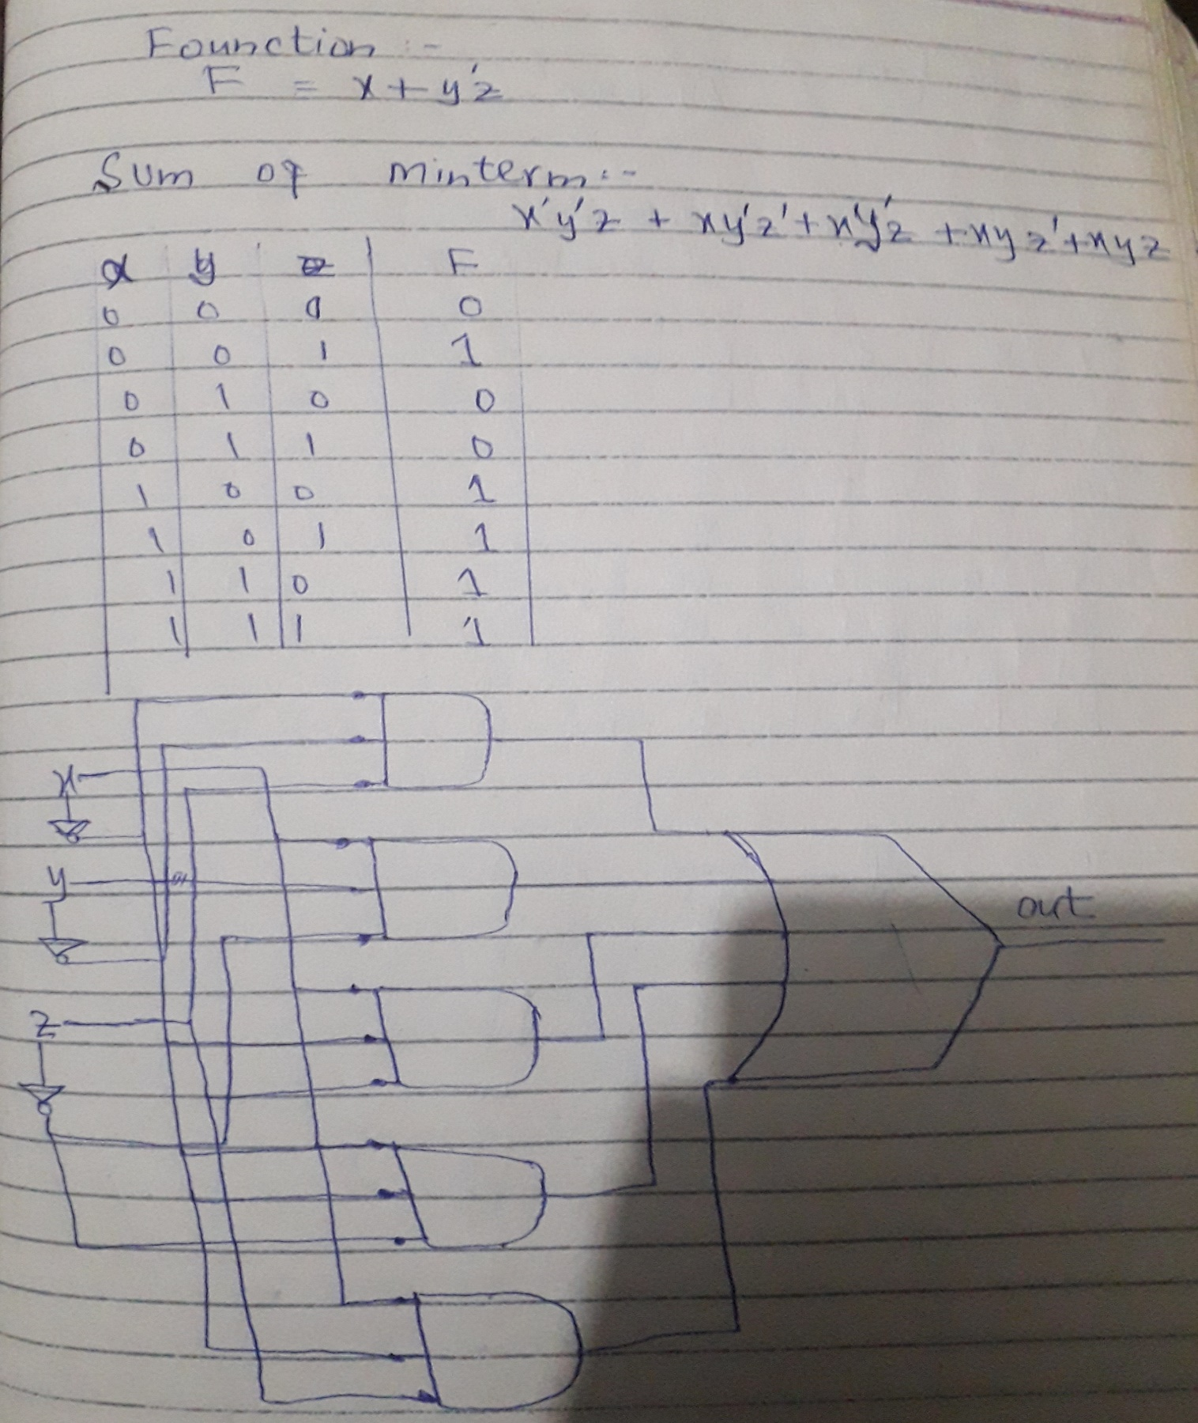

**No.4:-**

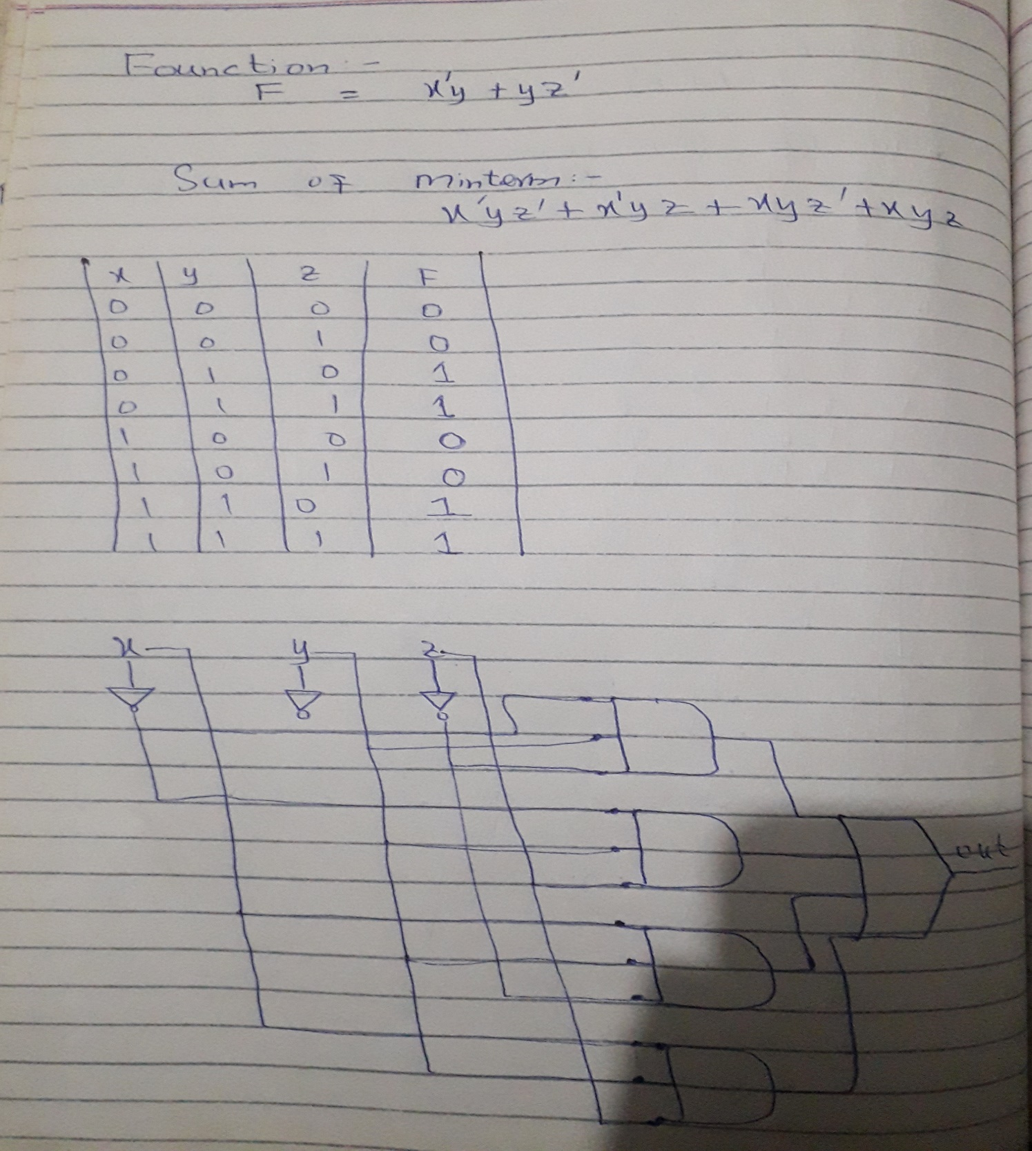

**No.5:-**

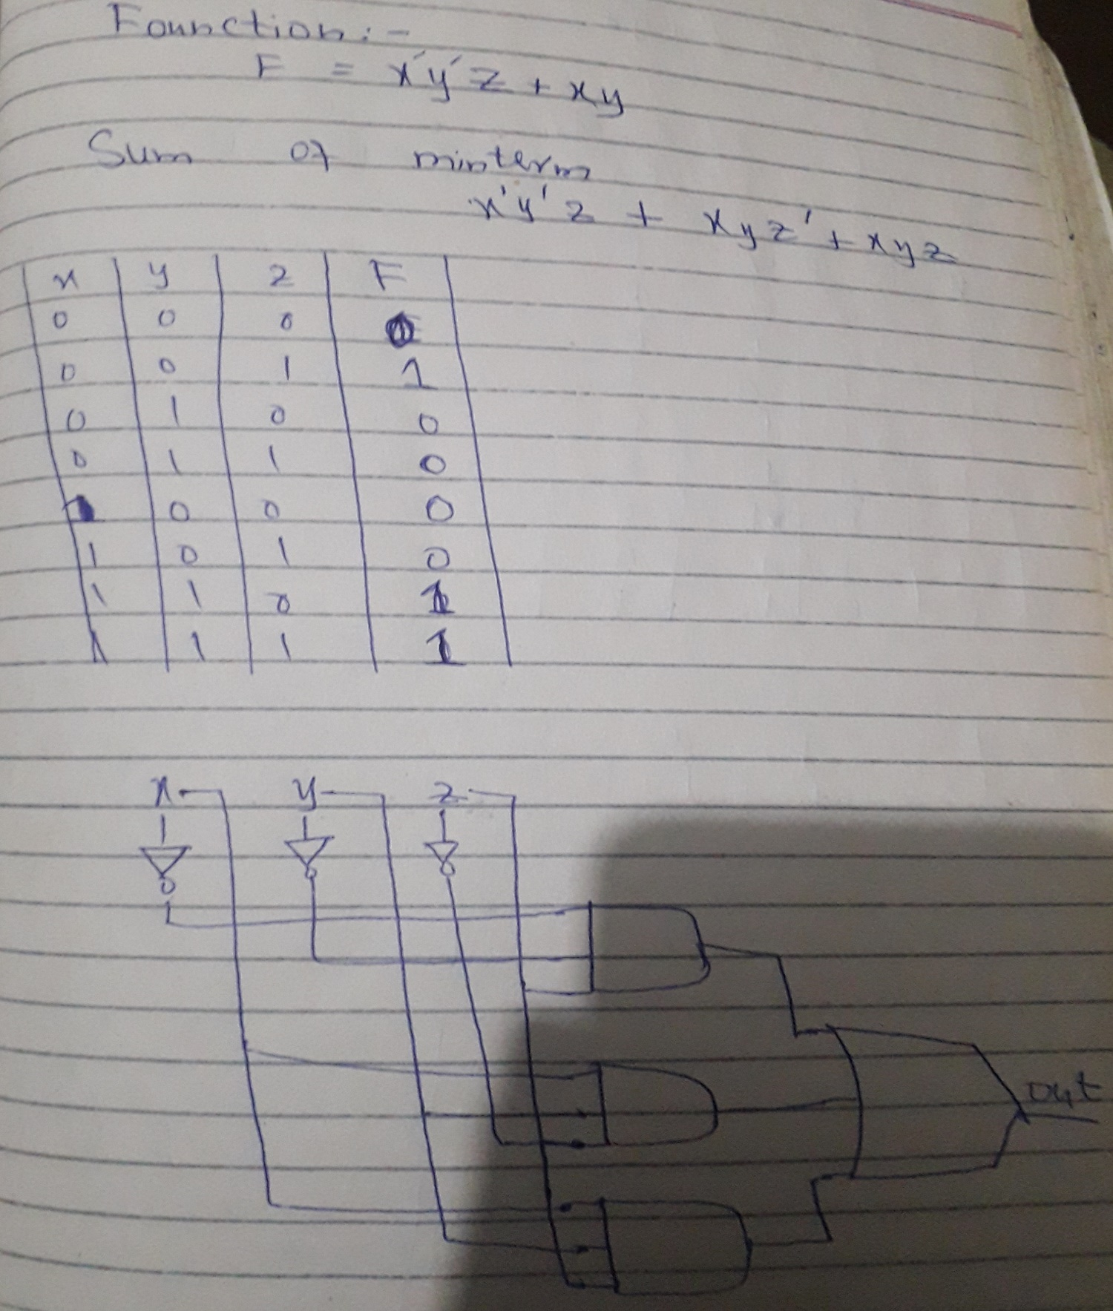

**No.6:-**

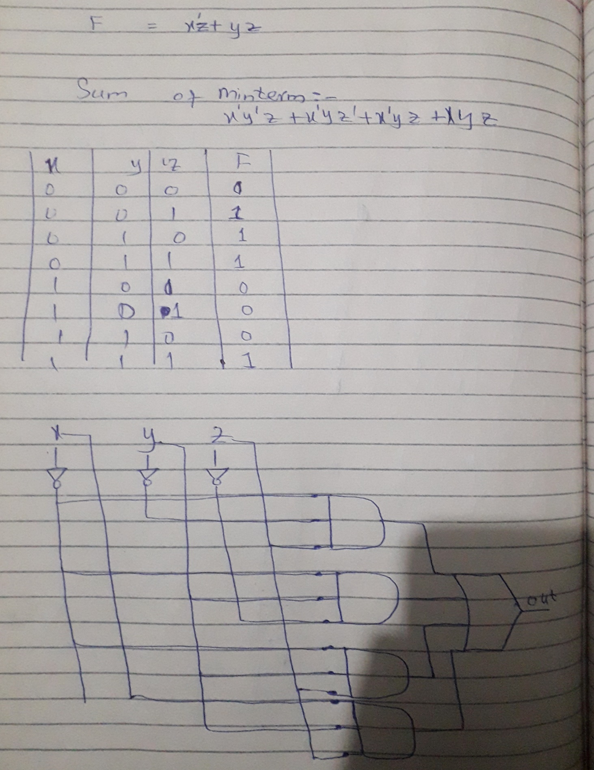

**No.7:-**

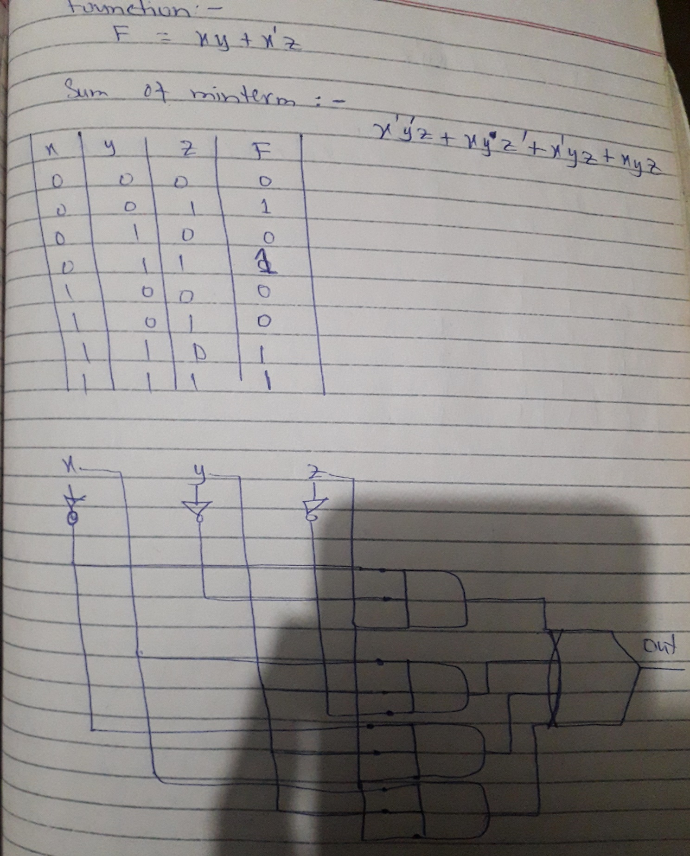

**No.8:-**

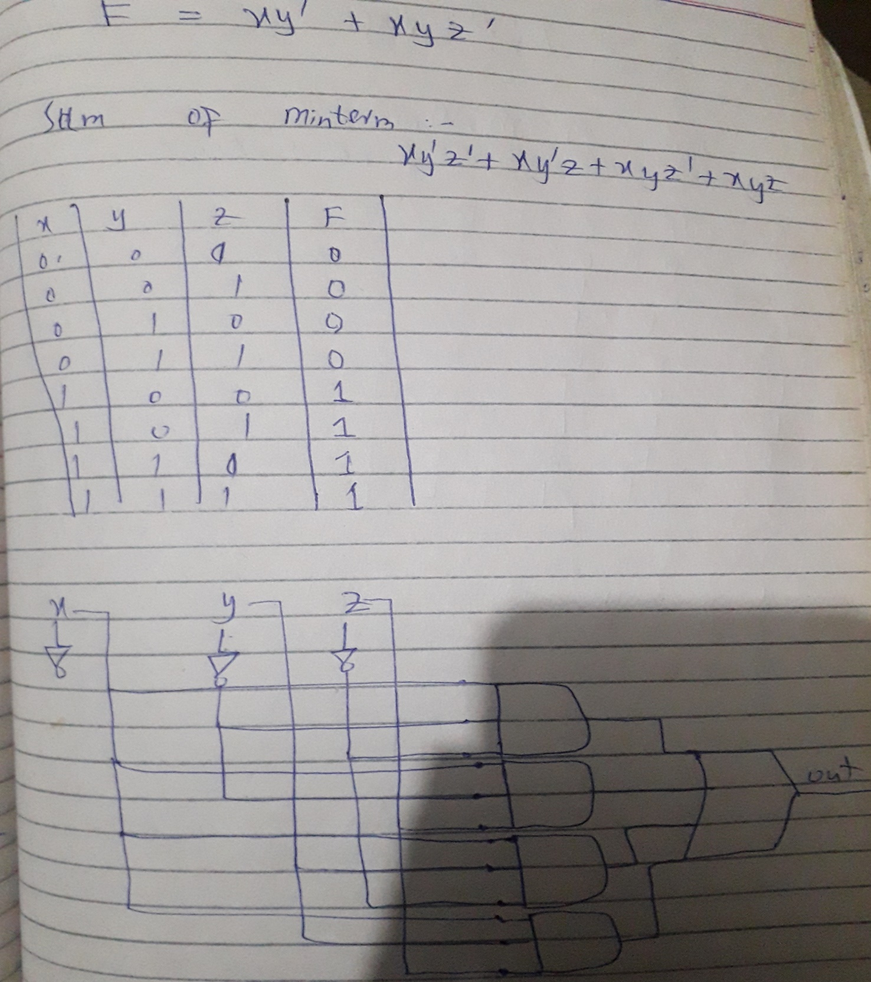

**No.9:-**

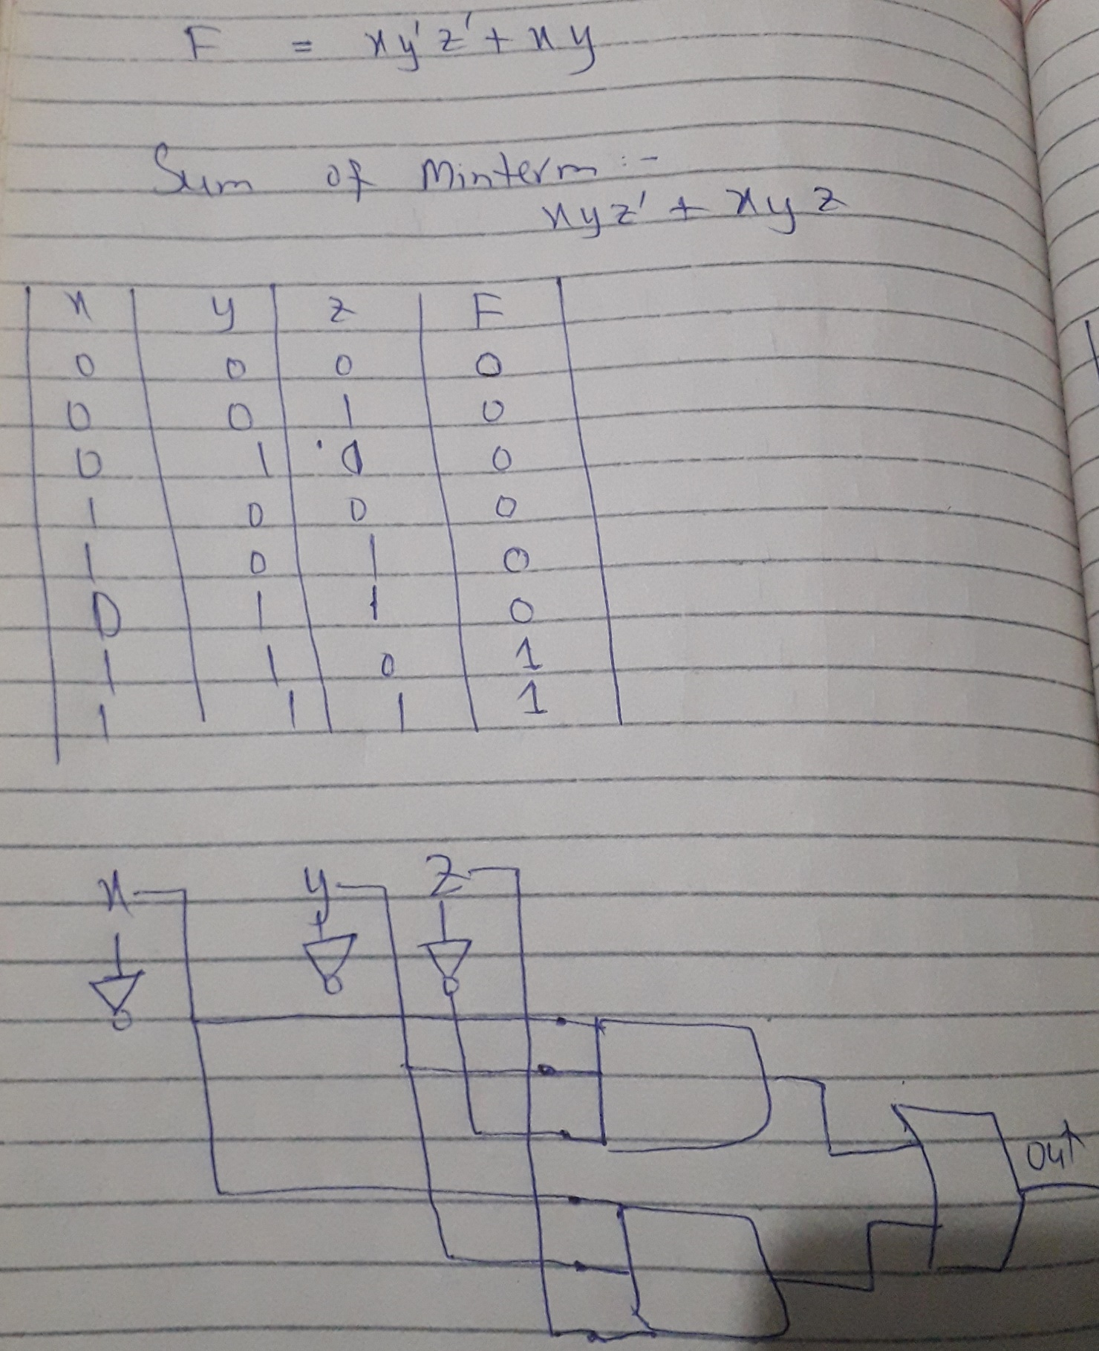

**No.10:-**

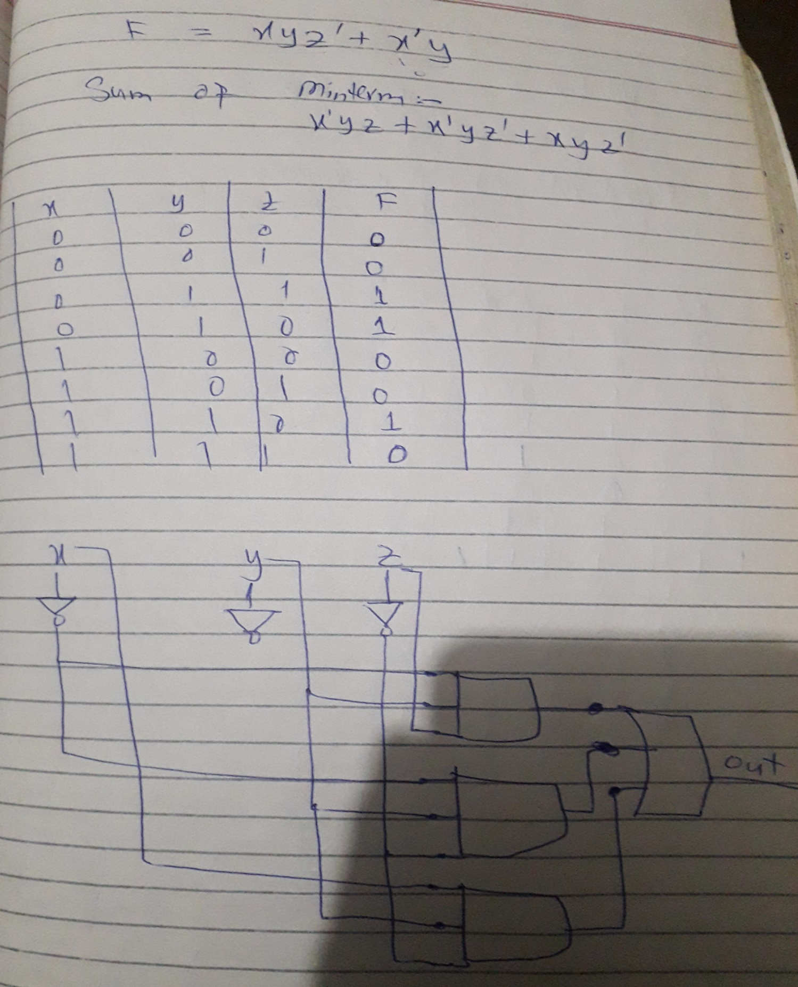

**Q.no:-Think of five 4-variable functions and design circuits for them using product-of-maxterms technique.**

**No.1:-**

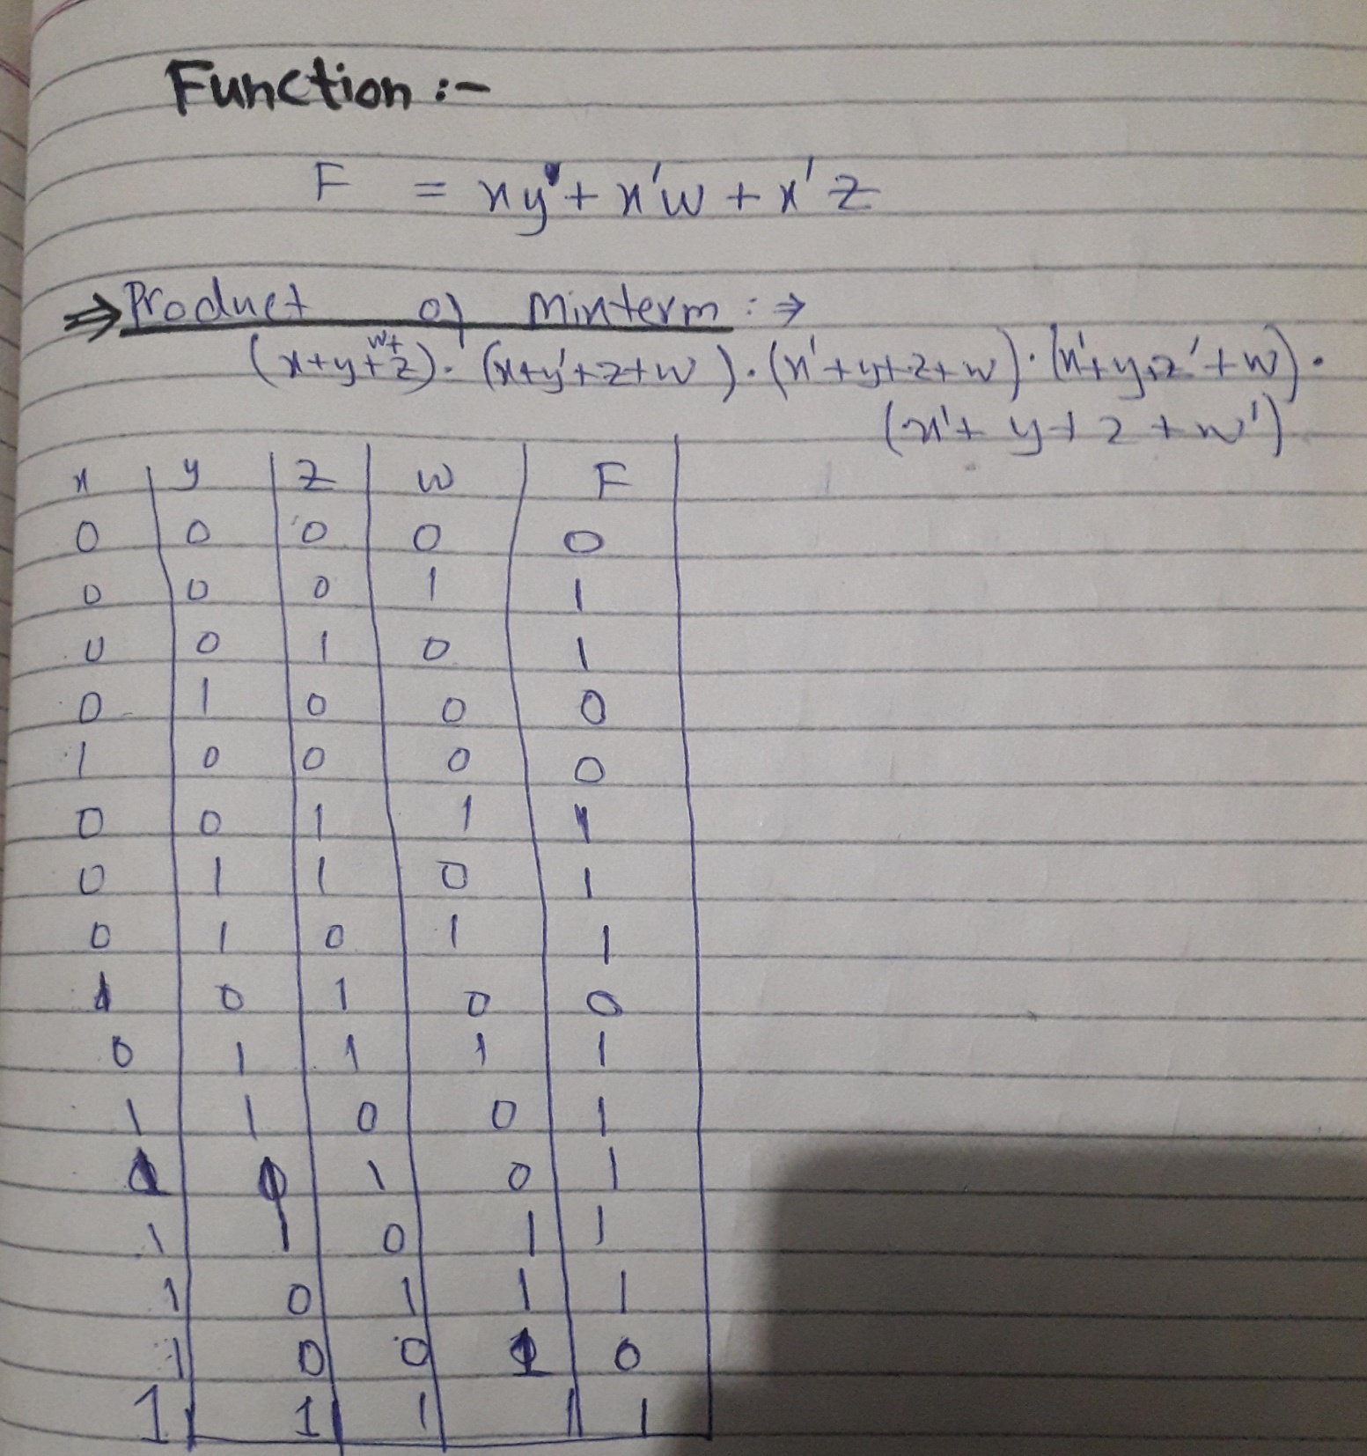

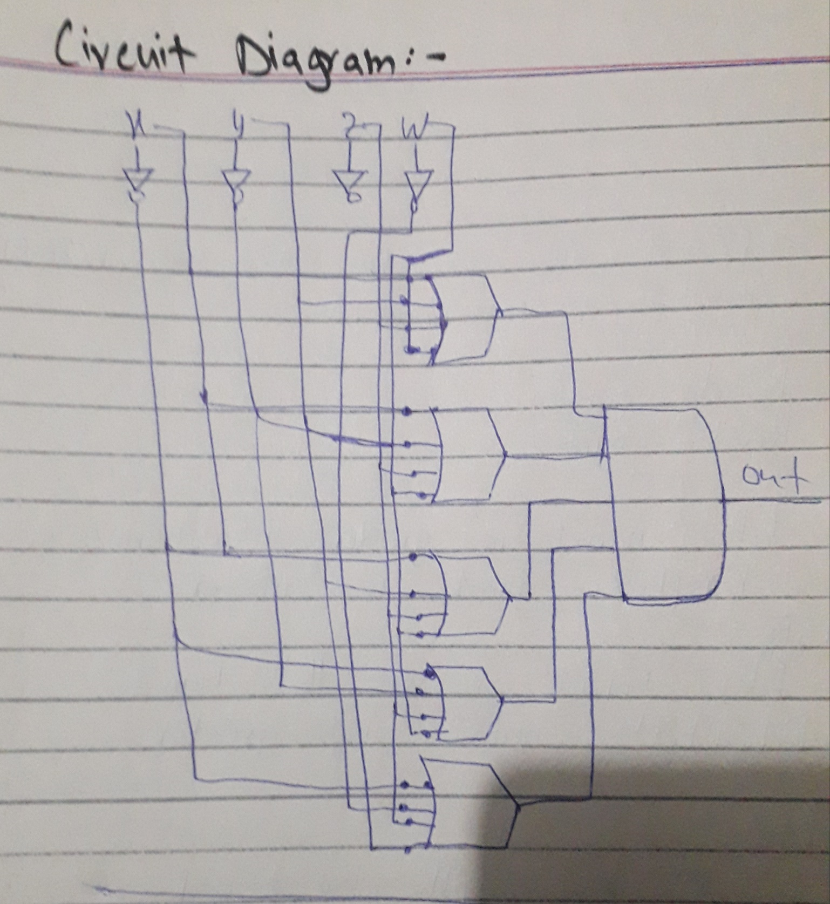

**No.2:- In this function product of mixterm is find by booleon algebra.**

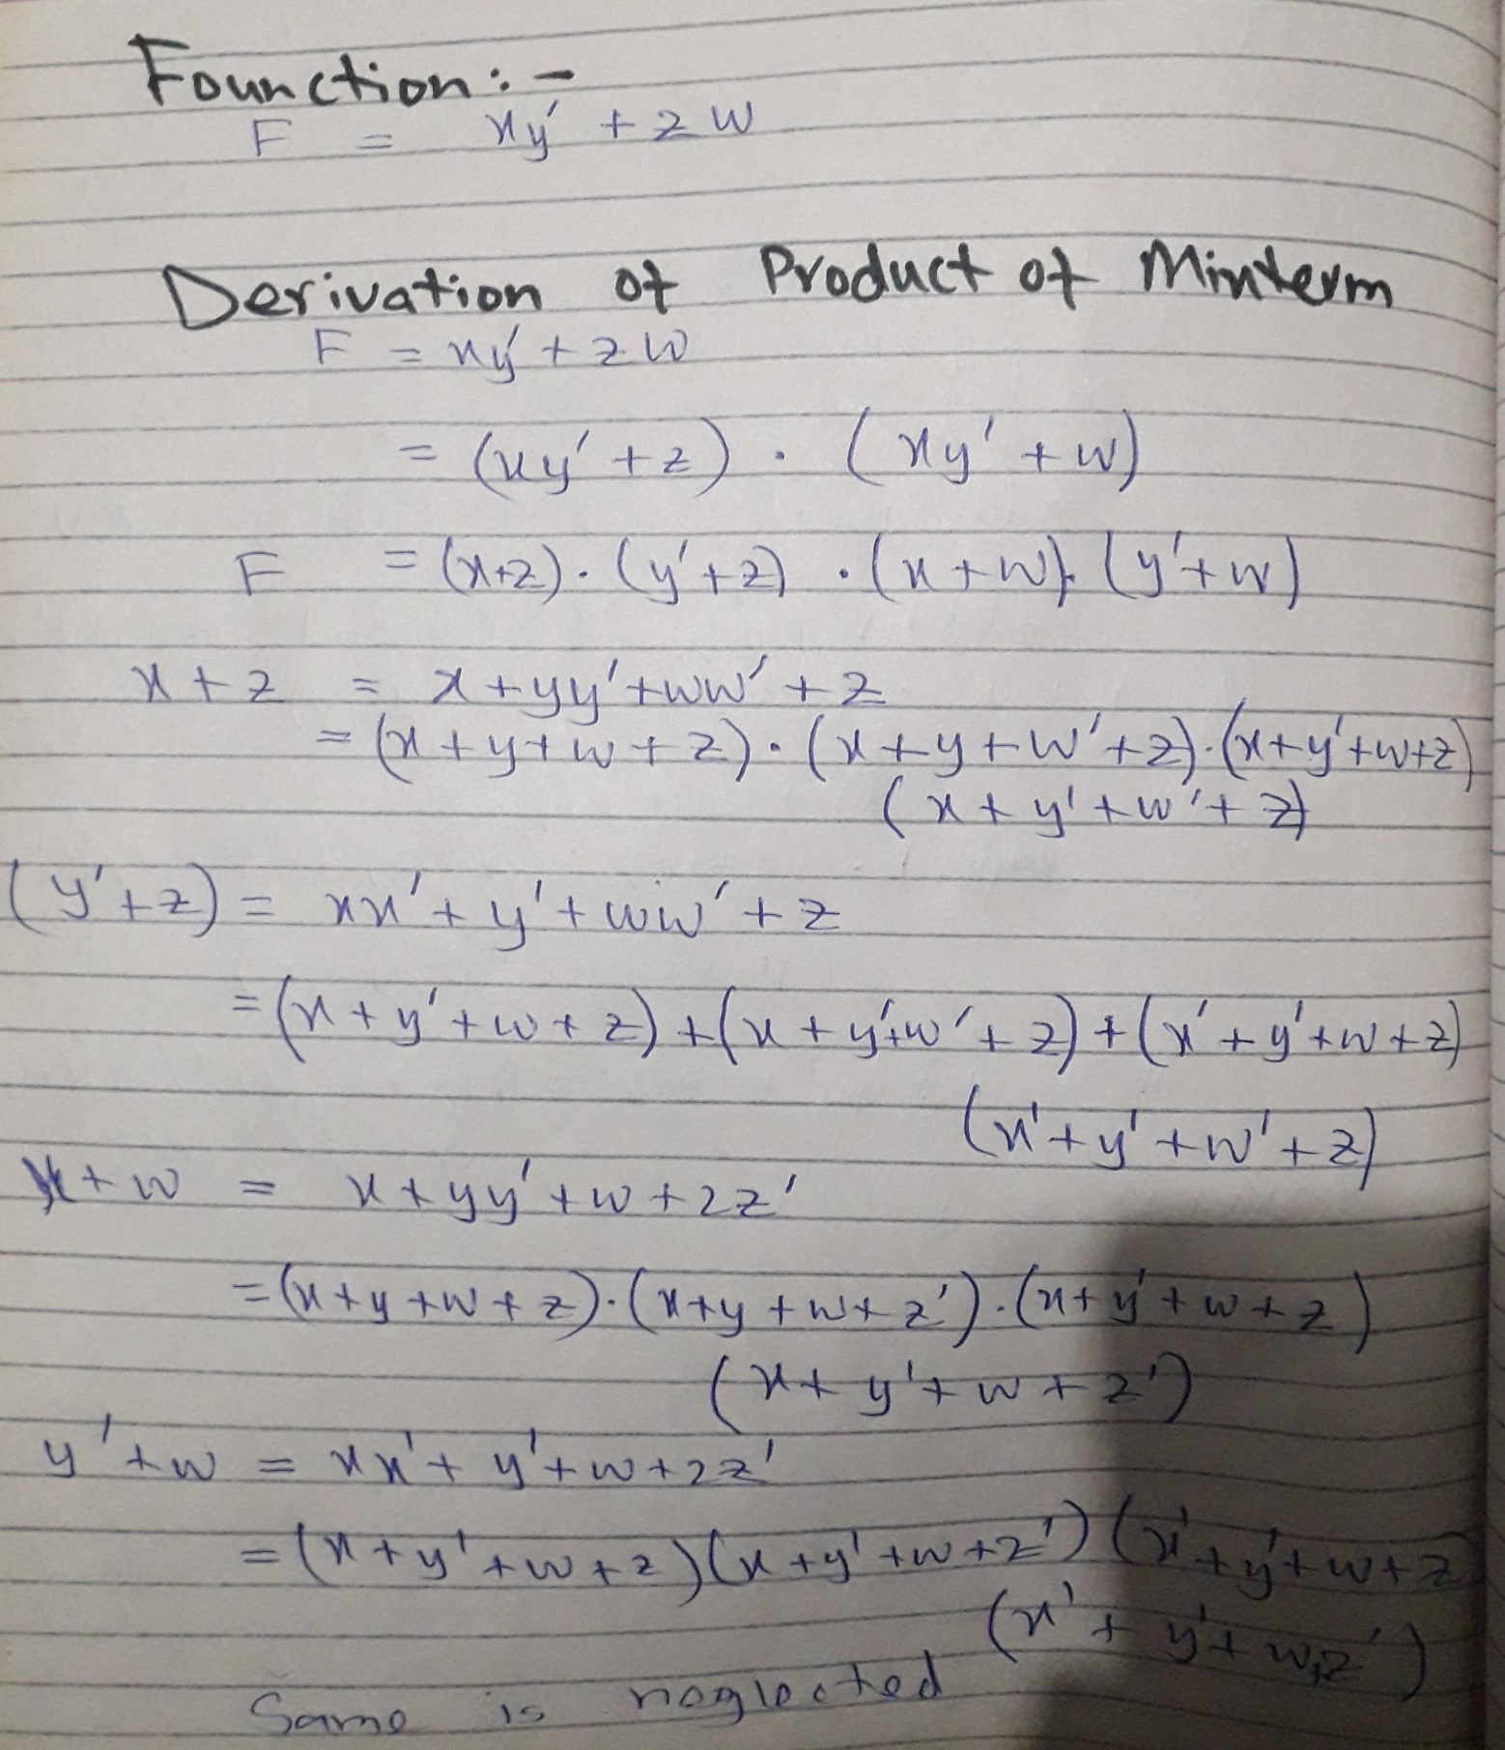

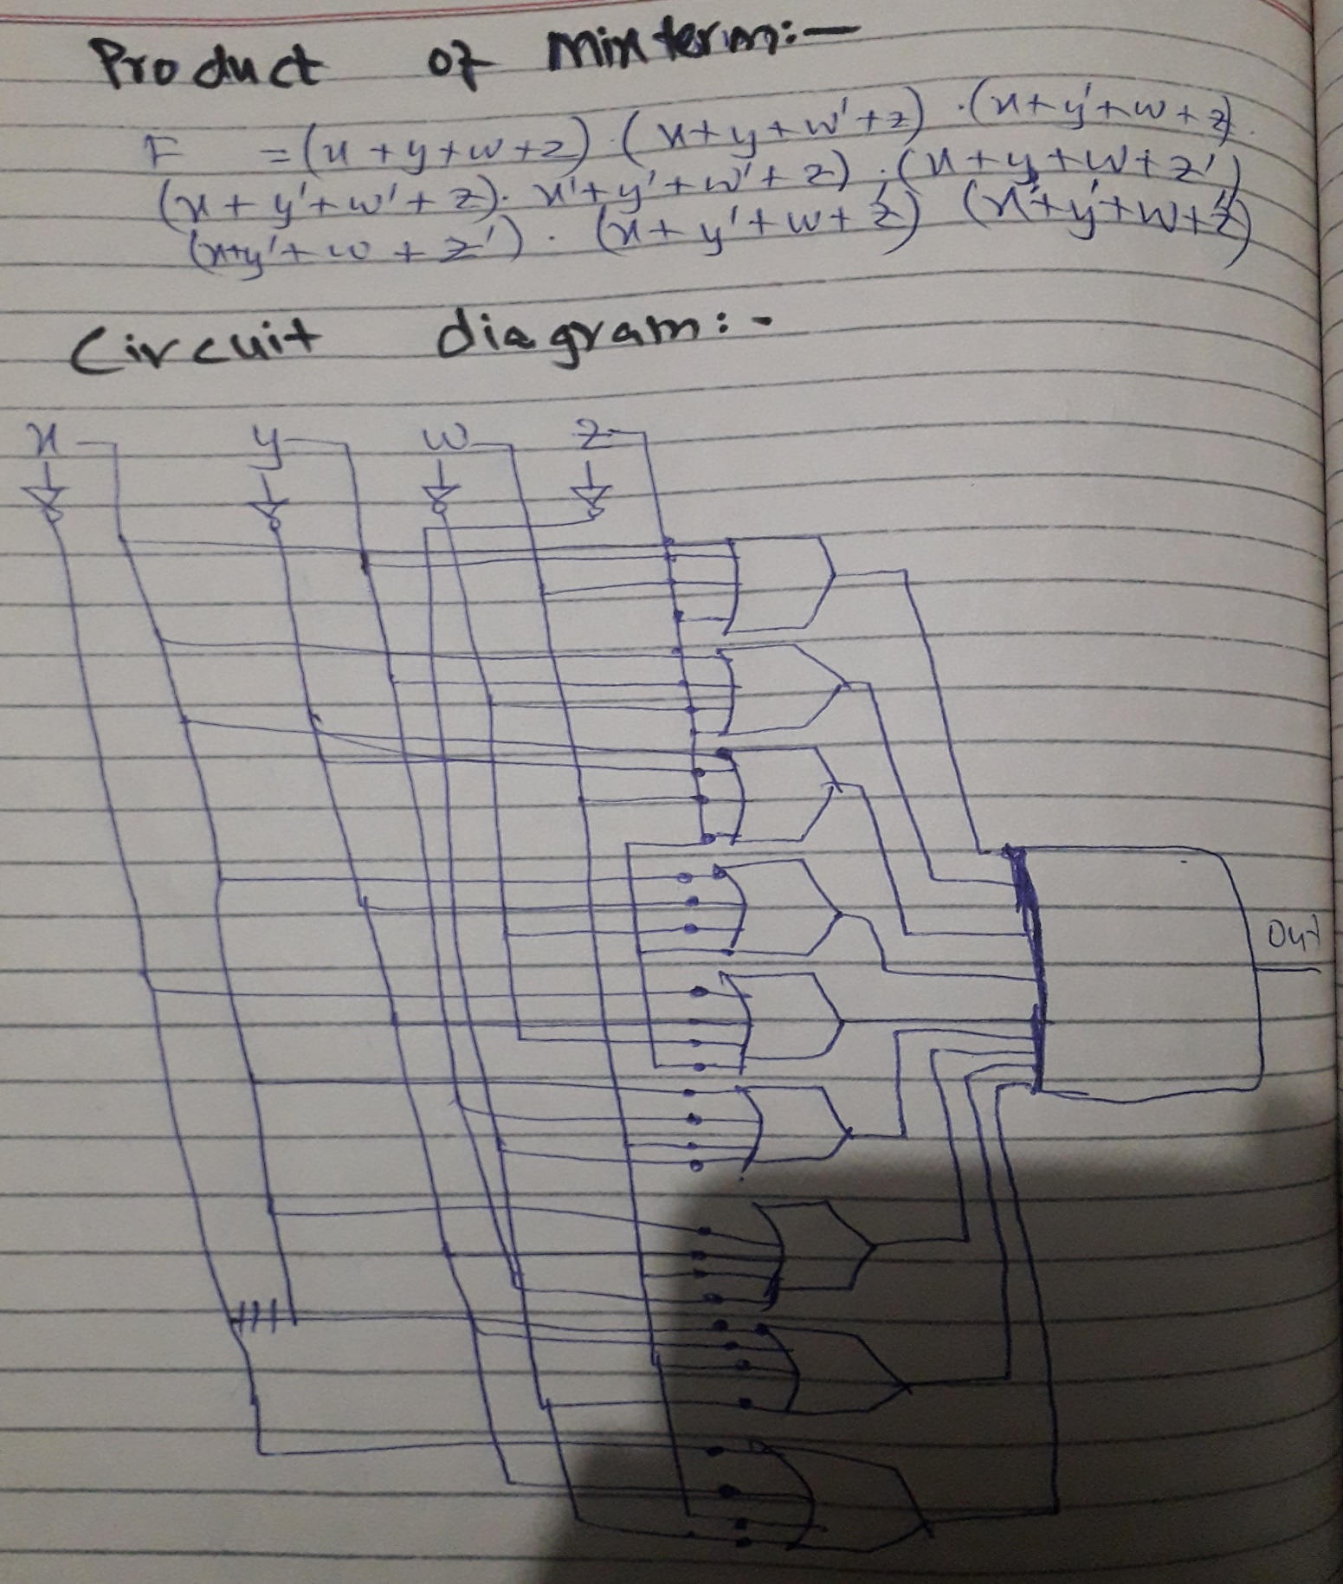

**No.3:-**

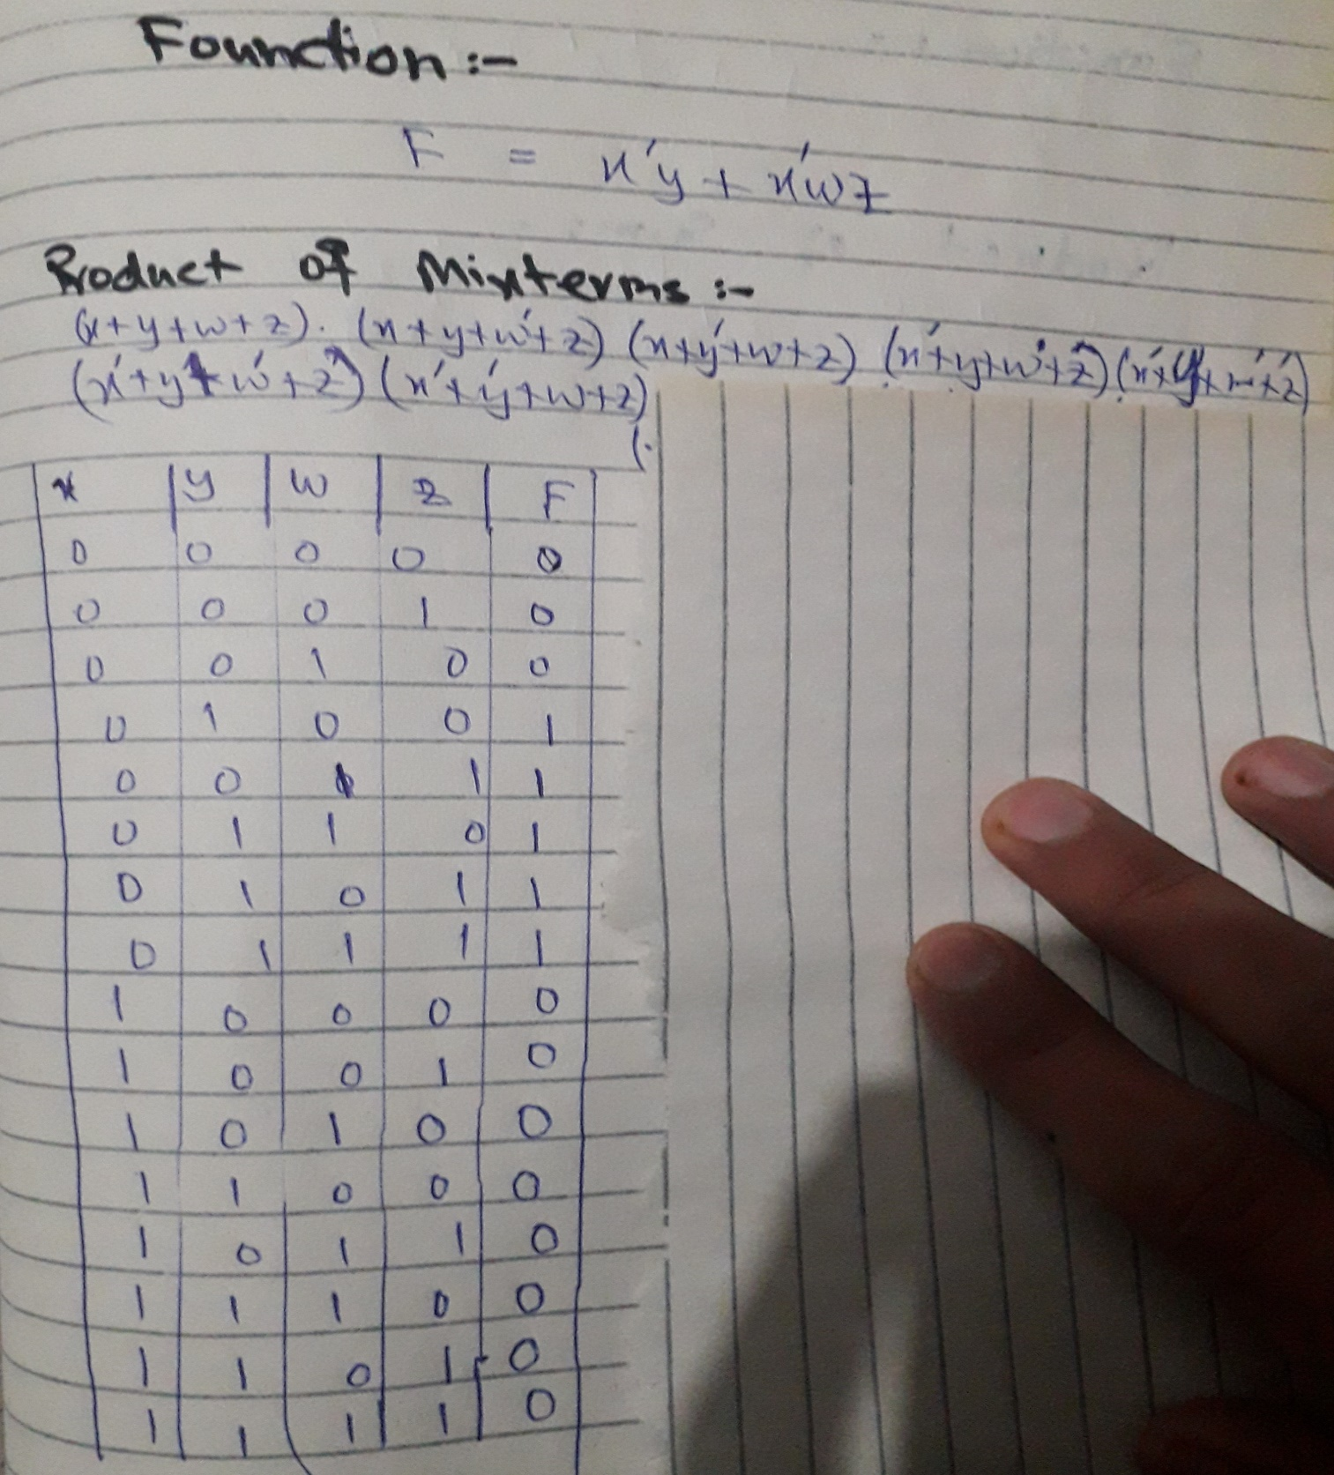

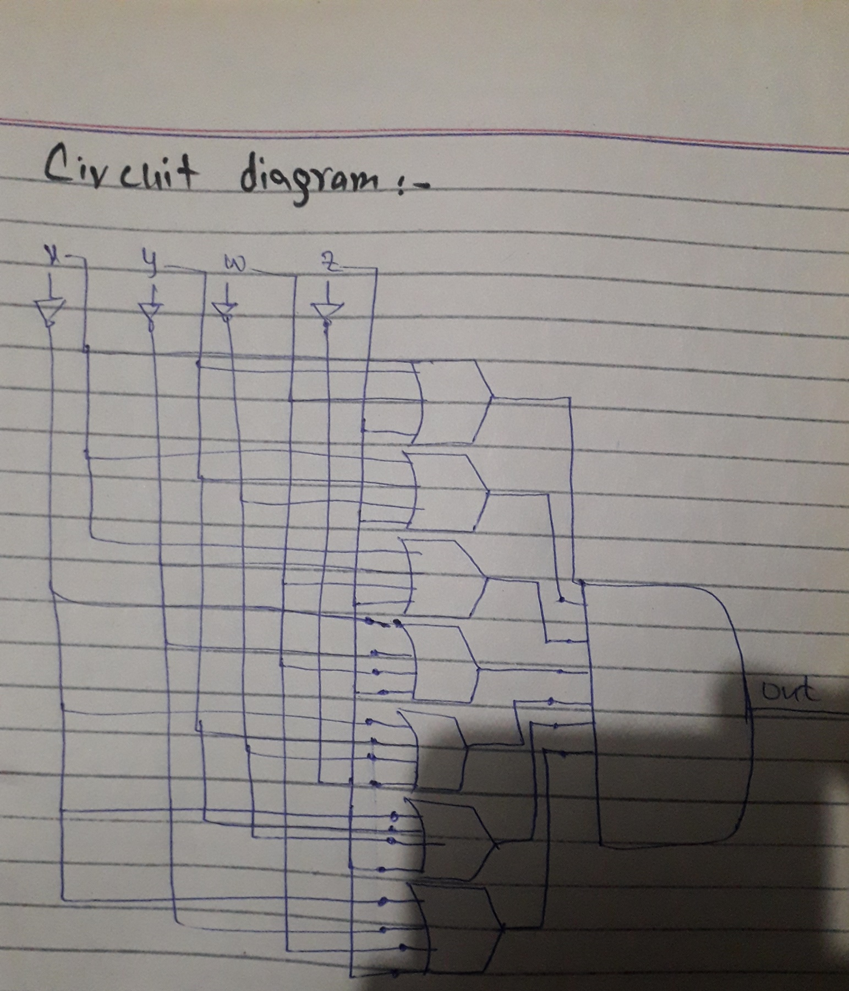

**No.4:-**

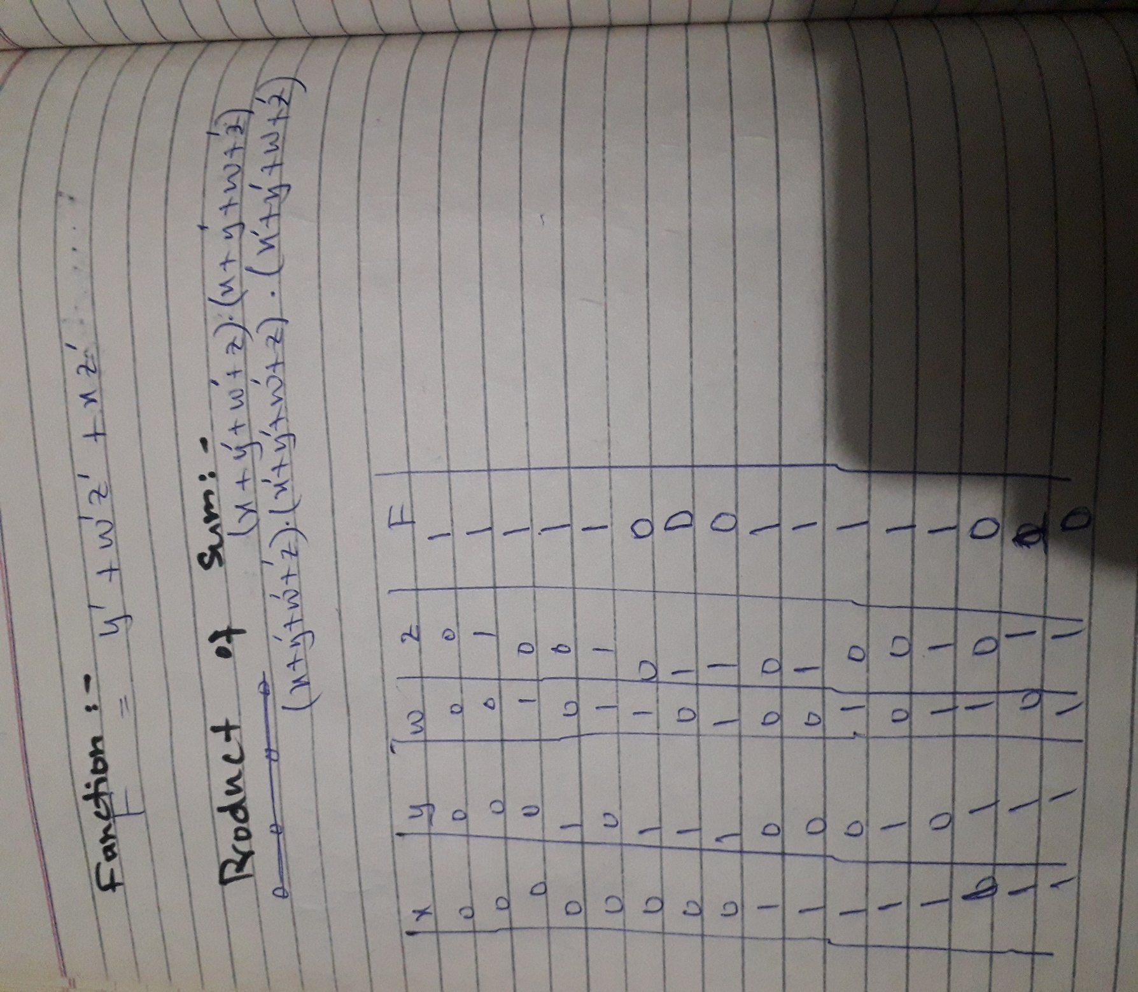

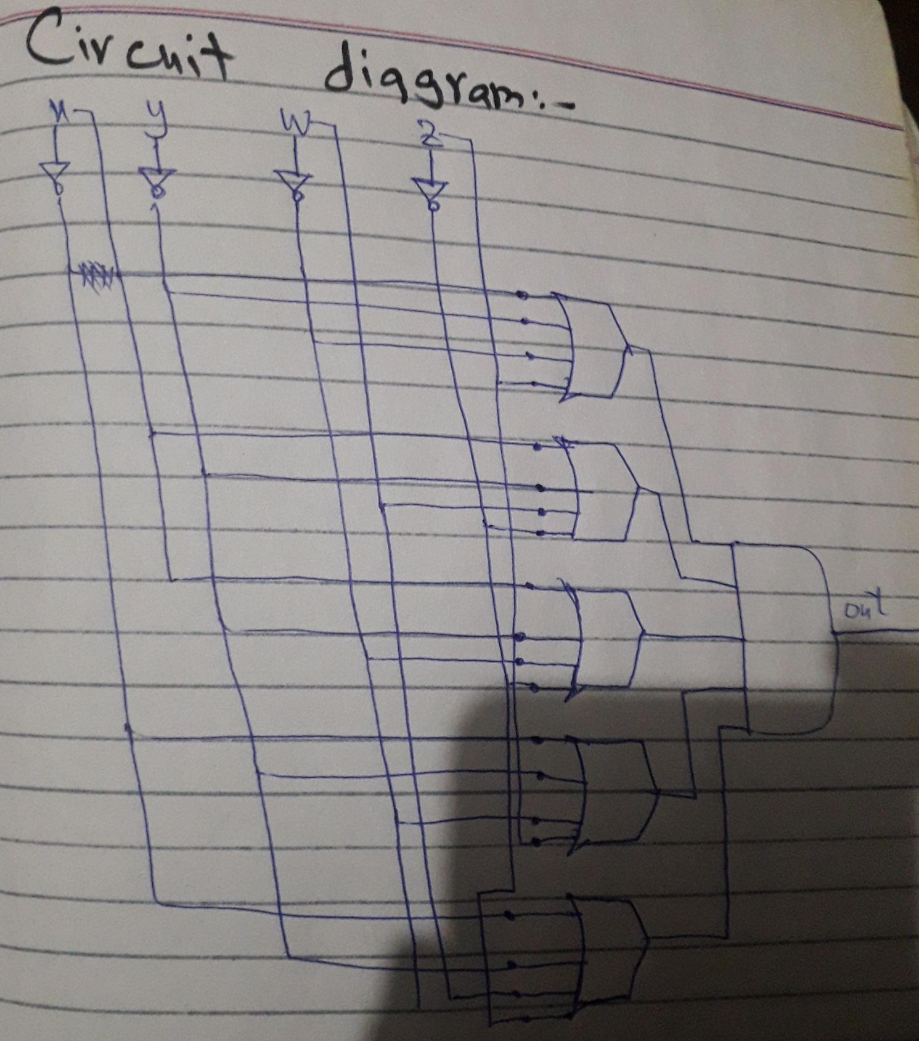

**No.5:-**

